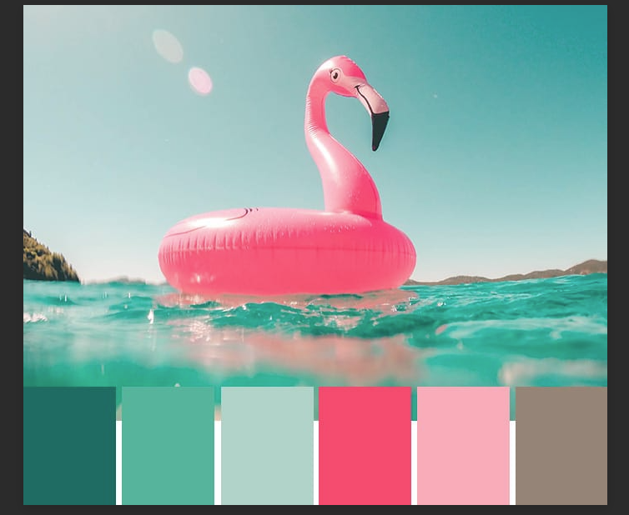

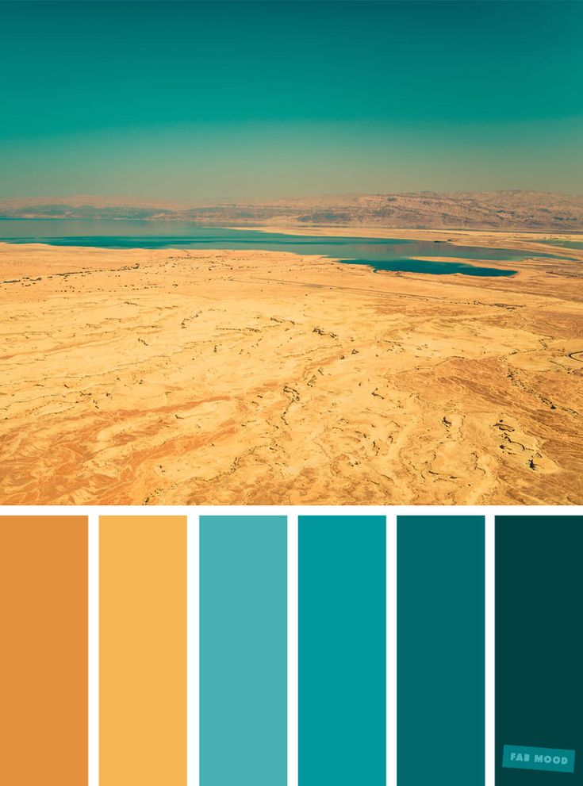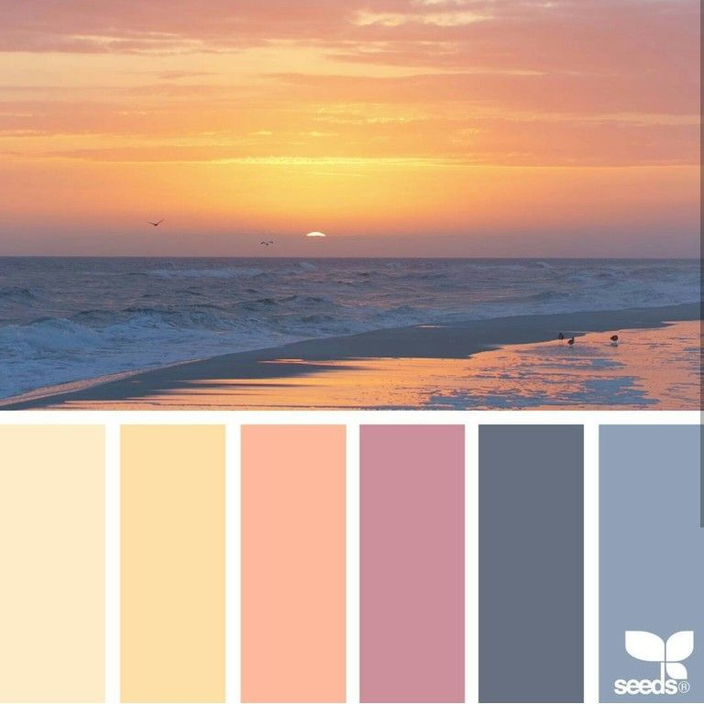

Some of the colour schemes we have chosen to use within our website. We have chosen a sort of Hawaiian/island theme for our website as the colours are very vibrant and unique which attracts a younger audience. The age range would be around 13-50 as often vibrant colours become less of a factor in older years. Nevertheless we feel this theme is not overbearing or too dull, but a good middle ground which would appeal to a wide general audience.